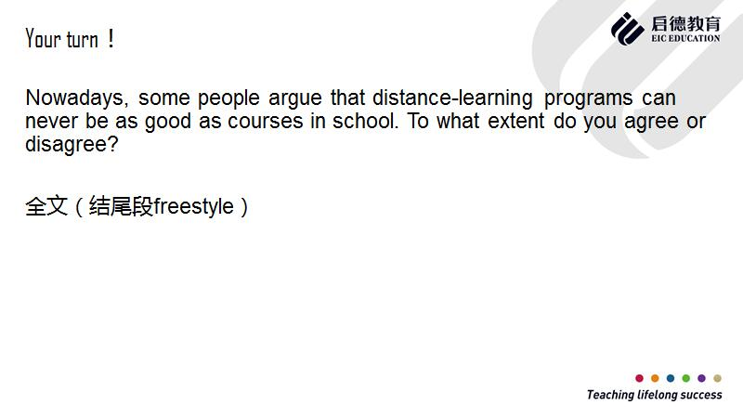

**DisAgree：远程教学和课堂教学一样好，甚至要更好?(不知道更好要不要说)**

**和课堂教学有一样的授课老师和知识点**

Distance-learning, like online course, has the same teacher and knowledge points as courses in school

**也可以布置作业来检测学生情况。**（具体化：使用软件提交作业，完成学习任务task）

Distance-learning can also give homework to students as task.

**同学和老师之间可以跟之前一样相互交流**。（具体化：使用聊天工具）

Students can discuss with teachers and classmates just like before.

**Agree：远程教学没有课堂教学好**

**学生的注意力没有课堂教学集中。**（具体化：受到像游戏，新闻，聊天影响的学生

Distance-learning may distract students from their studies.



Recently，Many citizens say distance-learning seems been thought have many shortcomings compared with courses in school. From my perspectives, I overall disagree with this opinion.

Distance-learning, like online course, has the same teacher and knowledge points as courses in school. Due to the familiar teaching style and the invariable studying aim, students who studying in home seems could take course just like they were in the classroom in school.(远程上课->因为有一样的老师和相同的知识点->所以给学生的感觉与课堂上课相似) Also, homework can be given to test the learning efficient for each students. Because of the development of Internet. Teachers could using application or software to hand out homework and students can hand in their answer, which is similar in school. (作业可以照样布置->因为网络的发展->所以老师和学生可以用应用布置作业和交作业)And finally, students can discuss with teachers and classmates by smartphone, like group discussion in collage. Because almost everyone has a social media account, so it is easy to connect with others and exchange idea of the opinion of the knowledge. (可以进行讨论->因为每个人都有社交账号->所以相互联络很方便)

But on the side, Distance-learning may distract students from their studies. Because games or online entertainment website like youtube, a video website, seems have more attract to teenagers, and also because online courses have no teacher to force you keep focused on studying, they may give in and hard to run away from the enjoyment.(会让人分心->游戏和网站更有吸引力+没有老师逼着学->很容易自甘堕落)

Overall, both the style of teachers teaching and the homework or discussion seems almost in the same mold between Distance-learning and courses in school, but there is something different: the environment of learning. When study in distance by oneself, it is not easy to keep our mind on study when there are so many joy things around us. But It depends on ourselves, and courses never changed. So Distance-learning is as well as courses in school